

**Dual-Axis Solar Tracking Array**

**Prepared by:**

Abdulrahman M. Al-Jayosi

Mohammad A. Al-Adham

Moutaz H. Abushabab

**Supervised by:**

Belal H. Sababha, PhD

Microprocessors & Embedded Systems Final Design Project

First Semester-2022/2023

***Abstract***

*This paper presents a two-axis solar tracking system that uses a PIC16F877A microcontroller to control the movement of the solar panels. The system is designed to optimize the energy output of the solar panels by continuously adjusting their orientation to follow the movement of the sun throughout the day. The PIC16F877A microcontroller is used to control the azimuth and altitude motors, which adjust the angle of the solar panels using the compare feature of the CCP module. The system includes four light-dependent resistor (L DR) sensor to detect the intensity of sunlight. The energy generated by the solar panels is stored in a battery, which is used to power the system's components. Under perfect conditions, the system's performance can increase the energy output of the solar panels by up to 30% compared to fixed solar panels.*

Contents

1. Introduction 3

1.1 Background 3

1.2 Objectives 4

2. Design 4

2.1 Requirements and components 4

2.2 Movement mechanism 5

2.4 LDR sensors and movement decision 6

2.5 Interfacing with the LCD 6

2.6 Power management 7

2.7 Current Measurement 7

2.8 Flow chart 9

2.8 Connection circuit diagram 10

3. Problems and recommendations 10

4. Conclusion 10

5. References 11

# Introduction

## Background

Two-axis solar trackers are devices that are used to optimize the performance of solar panels by adjusting their orientation to follow the movement of the sun throughout the day. These trackers use two motors, one for azimuth (horizontal) rotation and one for elevation (vertical) rotation, to continuously adjust the angle of the solar panels so that they are always perpendicular to the sun's rays.

The sun changes its position in the sky relative to us throughout the day and throughout the year. This affects solar panels’ ability to catch the sun’s rays and converting it to energy. Throughout the day the sun will move from east to west in a constantly changing solar azimuth angle. And day to day, the sun changes its declination angle; a solar declination is the angle formed between the equator plane and the line connecting earth’s core to the sun’s core, this changes the altitude angle, which is how high the sun is in the sky.

The use of two-axis trackers can significantly increase the efficiency of solar panels. By following the sun's movement, the panels can capture more energy than they would if they were fixed in one position. This can lead to an increase in the overall output of a solar installation, which can translate to a higher return on investment for the project.

Two-axis trackers also have the advantage of being able to generate more energy during the early morning and evening hours, when the sun is lower in the sky. This can help to smooth out the energy production of a solar installation over the course of the day, which can be beneficial for grid integration and energy management.

Two-axis solar trackers are relatively complex and expensive to manufacture and install, which can make them less cost-effective for some projects where returns are expected immediately, but it is a worthy investment for the long term. The additional energy production can offset the higher costs of the trackers over time, and their efficiency can also reduce the total number of panels needed for a project. Two-axis solar trackers also require more maintenance than fixed solar panels, as the motors and other moving parts need to be regularly serviced and maintained.

Two-axis solar trackers are also used on satellites to optimize the performance of the solar panels that provide power for the satellite's systems. These solar trackers are used to adjust the orientation of the solar panels so that they are always perpendicular to the sun's rays, which allows the panels to capture the maximum amount of energy possible.

Satellites in Low Earth Orbit (LEO) and Geosynchronous Earth Orbit (GEO) use two-axis solar trackers to track the sun. The use of these trackers allows the solar panels to maintain a constant angle to the sun, which maximizes the amount of energy they can generate. This is particularly important for satellites in low Earth orbit, as they experience rapid changes in the angle of the sun due to their fast orbital velocity.

The use of two-axis solar trackers on satellites can also help to reduce the overall weight and size of the satellite, as the panels can be designed to be smaller and more efficient. This can be important for reducing the cost of launching the satellite into orbit as it reduces the fuel and weight requirements.

## Objectives

In this project, we aim to design a mini solar tracking system that could be implemented on larger platforms and to develop an applicable engineering solution to demonstrate the working mechanisms of dual-axis solar trackers. The hardware consists of the PIC16F877A microcontroller, a 5W/12V solar panel to generate the required energy for the rest of the project, 4 LDR sensors, an LCD display, two SG90 servo motors, pan/tilt movement part, a rechargeable battery, battery management circuit, a platform to hold the solar panel, and an external circuit that interfaces the microcontroller to the rest of the system. There are two modes of operation, the first one is the sun tracking mode, where the system tracks the sun automatically and displays the power and voltage readings. The second mode is the manual control mode, where the user can move the panel to the desired position. The main operation of the system is as follows, when power is turned on, the system asks the user which mode of operation to run, then the user picks the desired mode through push buttons. There is an additional home button to get out of the operation being implemented and to ask the user to select the operation again.

# Design

## Requirements and components

Our project is required to do the following tasks:

* Track the sun horizontally and vertically.
* Measure the power generated by the solar panel and the voltage across it.
* Display the readings on the LCD screen.

The components required for these tasks are:

* PIC16F877A microcontroller.
* 5W/12V solar panel.
* LCD with HD44780U controller.
* Two SG90 servo motors.
* 3D printed Pan/Tilt platform.
* Solar panel holder.
* ACS712 current sensor.
* 3.7V 4800mAh rechargeable battery.
* 134N3P DC to DC boost converter.
* CN3065 solar charger for lithium-ion batteries.
* Resistors and potentiometers.
* Two breadboards and cables.
* 8 MHz piezoelectric material crystal oscillator.
* LM358 Operational amplifier.
* A box to house the external circuit and stand to hold the solar panel.

## Movement mechanism

To achieve precise movement in two axes, we need two position control motors. SG90 servo motor (shown in figure 1) is a low-cost and relatively high-torque motor that can do this task. A pan and tilt mechanism that fits the SG90 servo motor is also required to move the solar panel horizontally and vertically.

The first servo motor is used to control the horizontal movement (hidden inside the pan and tilt component), and the second servo motor moves on the vertical axis (shown up in figure 1). SG90 servo motor moves 180 degrees (0 degrees to 180 is our reference for angle). The position of a servo motor is controlled by a 50 Hz pulse width modulated signal. For the servo to move to angle 0 for example, we need a PWM input signal with a duty cycle of 3% (600 us pulse width). For a maximum angle (180 degrees), the duty cycle should be 12.5%. The angle of the servo motor is linearly proportional to the width of the PWM input signal. This means the angle of a servo is related to the duty cycle of the PWM signal in the following equation.

$$Angle \left(Degrees\right)= 18.9473684×Duty cycle \left(Percent\%\right)-56.84210526°$$

The input PWM input signal will be generated by the PIC16F877A using the compare mode in the CCP module. We will not use the PWM mode because we are operating on an 8.0 MHz clock frequency, which makes the least possible PWM frequency equal to 488.28125 Hz (period = 2.048 ms). The compare mode is not designed to generate PWM signals but we can use it to generate one using timer1 (which is a 16-bit timer) in the following technique, first, we set the two CCP modules in the compare mode to generate software interrupts when the value of timer1 matches the value stored in CCPRXH:CCPRXL special function registers in the SRAM. Then we enable all the related interrupts in the INTCON, PIE1, and PIE2 registers. After that, we enable timer1 and make it operate on a Prescaler 1:1, which makes timer1 overflow each 32 ms (when it counts to 65535). To generate a PWM with a period equal to 20 ms, we initially store 40,000 in CCPRXH:CCPRXL, then when timer1 counts to 40,000, we set the value of the output pin, clear timer1, and store the required value in the CCPRXH:CCPRXL for our duty cycle in the interrupt service routine. After that, when timer1 counts to the required duty cycle value in CCPRXH:CCPRXL, we will reset the output pin and store 40,000 once again in CCPRXH:CCPRXL in the interrupt service routine, and wait until it counts to 40,000 again and do the same steps done before, and this cycle will be repeated again and again. In the c source code, we defined two unsigned integer variables (Four bytes in the SRAM) to control the angle of the two servo motors (one for every servo motor). The value of these variables is related to the angle of the 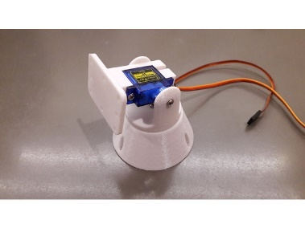two servos by the following equation.

Figure 1 Pan and tilt part (eltitomanolo, 2017)

$$Angle \left(Degrees\right)=0.0473684×Duty cycle variable -56.84210526°$$

## 2.4 LDR sensors and movement decision

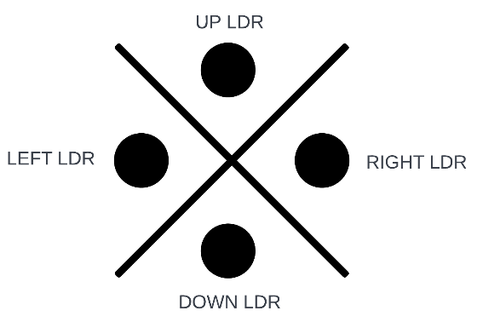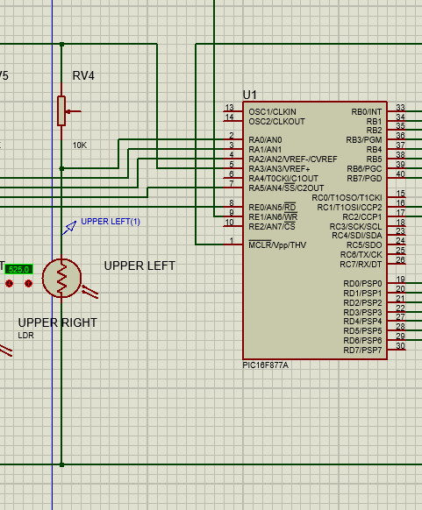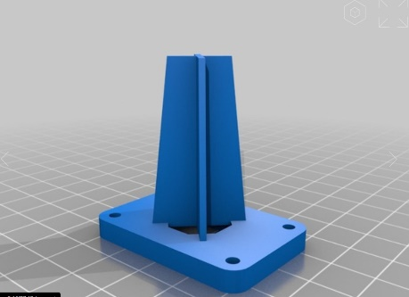For our project to track the sun we need, we need a sensor that detects light. A photoresistor also known as LDR (Light dependent resistor) changes its resistance with light. When the light intensity or illuminance (Lux) increases, the LDR resistance decreases, and when the light intensity or illuminance decreases, the LDR resistance increase. If we connected the LDR in a voltage divider connection (shown in figure 2) and took the LDR voltage as an analog input to one of the PIC analog pins, at high light intensities, the voltage of the LDR will be low, and at low light intensities, the voltage of the LDR will be high. If we placed the LDRs as shown in figure 3 and figure 4, in this configuration, we have isolated the LDRs from each other. For example, if the light is high from the right LDR (shown in figure 4), the isolating structure will block the incident light and none of the other LDRs will receive the incident light. In our project, we have connected the left LDR to RA0/AN0, the right LDR to RA1/AN1, the up LDR to RA2/AN2, and the down LDR to RA5/AN5. RA3/AN3 will be the voltage reference which will be 3V. In the program source code, we store the voltage value of each LDR in an integer variable (which will be between 0 and 1023, because the AD unit generates only 10 bits), then compare the value of the right LDR with the left, if the left is higher than the right (which means that light intensity at the right LDR is higher than the left LDR), the PIC makes the horizontal LDR move towards the right (by decreasing the duty cycle of the horizontal servo). The same is done with the left, up, and down values.

Figure 4 LDR configuration

Figure 2 LDR voltage divider connection

Figure 3 LDR isolating structure (eltitomanolo, 2017)

## 2.5 Interfacing with the LCD

We chose the LCD because it is a low-cost component that fits our needs in displaying the information to the user, and also it is simple in a way that makes operating it with the PIC microcontroller possible. We will interface the LCD with the PIC in the 4-bits mode. This interfacing has its advantages and disadvantages, it makes the program slower (because we are sending the data nibble than a nibble), but we will save four more pins for other functions. The HD44780 is the controller that controls the liquid crystal display, and it is connected to the LCD in a single printed circuit board as shown in figure 5. This board has 16 pins, pin functions are described in the following table.

Table 1 LCD pin description

|  |  |
| --- | --- |
| Pin | Function |
| Vss | Connected to the ground |
| Vdd | Connected to the power supply (5V in our design) |
| Vo | Contrast (5V for brightest digit display and 0 for lowest digit display) |
| Rs | Register select pin (0 for commands and 1 for data) |
| R/W | 0 for write and 1 for read |
| E | Enable pin |
| D0 to D7 | Data bits (D0 to D3 are grounded in our design because we are operating in the 4-bits mode) |
| A | Anode (for the background LED) |
| K | Cathode (for the background LED) |

To send commands to the LCD, we reset the Rs and R/W pins, then send the commands in the pins D4 to D7. If we want to write (display) characters in the LCD, we set Rs and reset R/W then send the character data as in the ASCII table.

When sending commands and data to the LCD, we send the 3 most significant bits with D7 being high then we set the enable pin after that we reset it (the commands and data are being processed by the LCD on a falling edge for the enable input), then send the least significant bits. Common commands are shown in the datasheet of the HD44780 driver.

## Power management

For powering up the project, we will use the 3.7V rechargeable battery to store the energy coming from the solar panel, then we will connect the battery to a 134N3P DC to DC boost converter to raise the value of the voltage to 5V with a relatively low power loss in the boost converter. The solar panel will charge the battery through a solar charger which will regulate the charging process.

## Current Measurement

To measure the current, a current sensor is used. The current sensor generates an analog signal which we must convert to digital using the PIC’s ADC converter. However, the ACS712 current sensor used starts at 2.5V for zero current and increases by 185 mV for every ampere up to a 3.425V reading at 5A. Since our maximum current is way below 1A, and therefore the resolution of the current output will be horrible, two Operational amplifiers are used to convert the range of 2.5-2.685V range to 0-3V to use the ADC’s full 10 without the issue of quantisation error. Figure 5 shows the circuit diagram for the Opams.

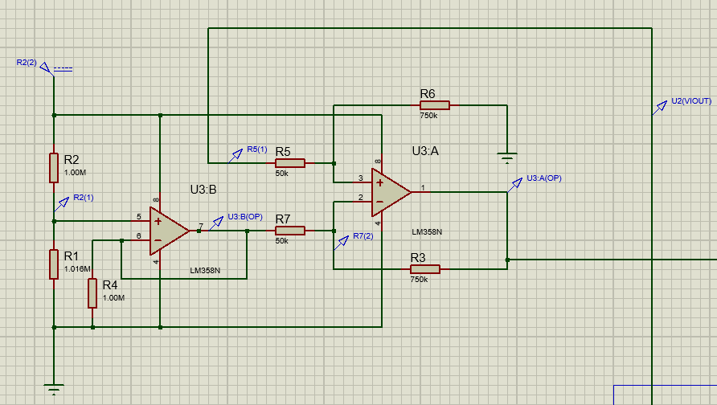

Figure 5 Opamp Circuit

## Flow chart

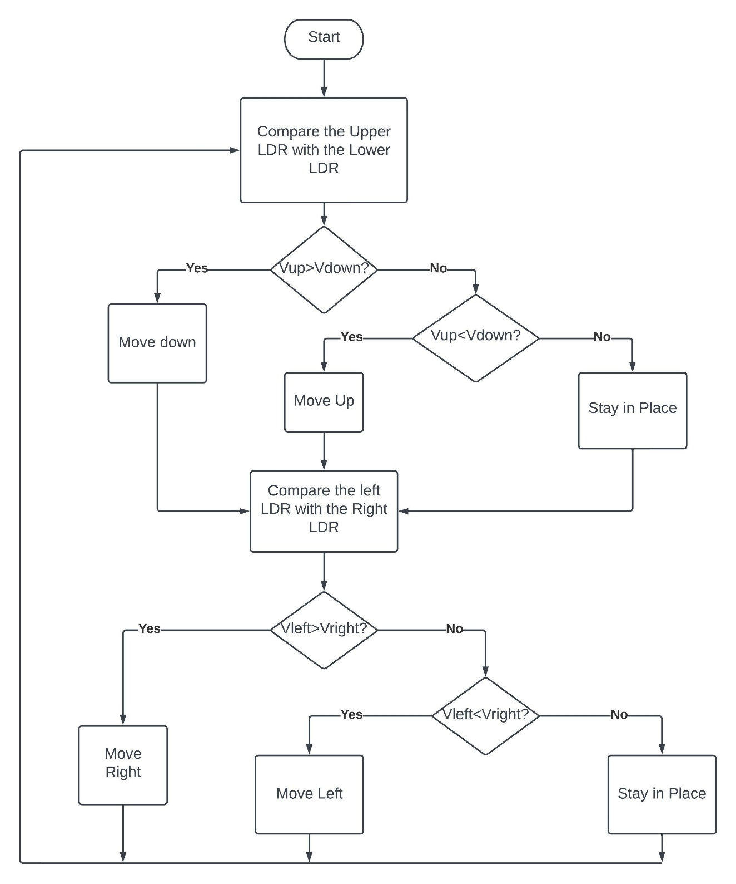

Figure 6 Software flow chart

## 2.8 Connection circuit diagram

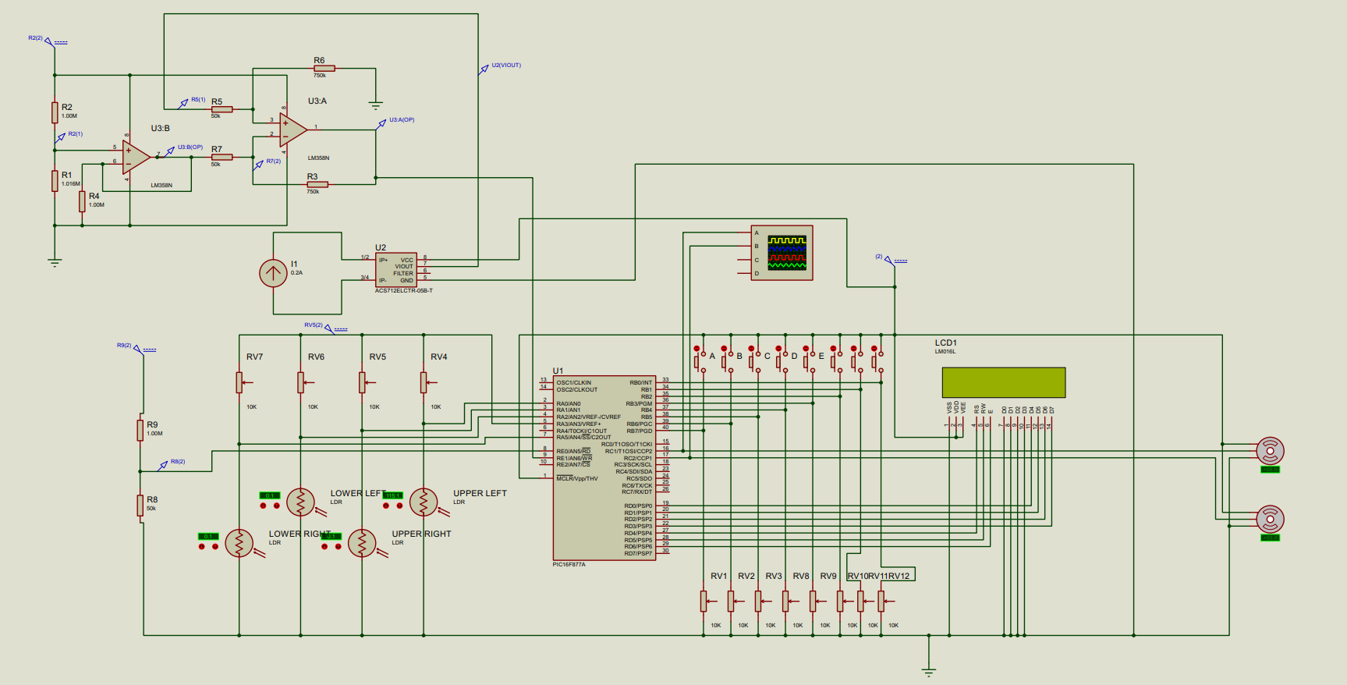

Figure 7 Project circuit connection

# Problems and recommendations

One problem that faced the project is low quality components, this is a huge problem as identifying mistakes was harder as it was not clear whether there was a mistake in the code, connections, or the parts. Many parts sold in Jordan are not original and come without quality assurance and consistency that is supposed to be for such components, LDRs and batteries especially lack official documentation and data sheets. This problem needs constant buying of parts and a trial-and-error approach to problem solving.

Another problem that faced us is the fast battery drain, this is caused by the low-quality battery as well as the running of two servomotors on battery power. The constant drain of power caused the system to behave weirdly as the LCD would flicker and the servo-motors would not operate if the battery has a very low voltage. This was solved by using a constant power supply for the video. During the Presentation, the battery will be fully charged.

# 4. Conclusion

In conclusion, two-axis solar trackers are an effective way to increase the efficiency of solar panels and to generate more energy over the course of the day. While they are more complex and expensive than fixed panels, they can ultimately lead to a higher return on investment for a solar installation.We have used the PIC16F877a MCU to control two servo motors using four LDRs in order to get the solar panel to face the sun.

Since the aim of the project was to track the sun's movement throughout the sky, then it successfully did that.

However, many aspects of this project could be improved to allow for a more stable and secure system. One aspect that needs to be improved is the sorting of the electronic components, as some parts sold in Jordan lack the quality assurance and consistency that is supposed to be for such components, LDRs and batteries especially lack official documentation and data sheets.

# 5. References

[Masters](https://www.wiley.com/en-us/search?pq=%7Crelevance%7Cauthor%3AGilbert+M.+Masters), [Gilbert](https://www.wiley.com/en-us/search?pq=%7Crelevance%7Cauthor%3AGilbert+M.+Masters) , Renewable and Efficient Electric Power Systems, 2013

Designing Embedded Systems with PIC Microcontrollers Principles and Applications, 2nd edition, 2009, Tim Wilmshurst, ISBN: 978-1-85617-750-4 2. Hardware: PIC16F877A